1. Download the data file named “M2.csv” and read the data into your project. Name the data as “market” and explore the data.

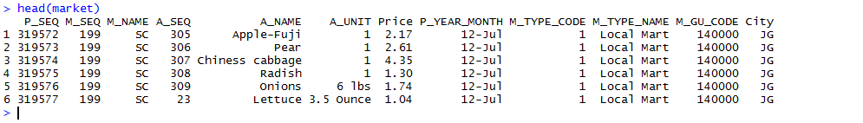

1. Apply the “Split-Apply-Combine” approach to the below figure using “tapply,” “by,” and “ddply” functions.

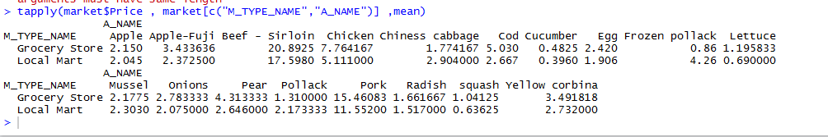

b)

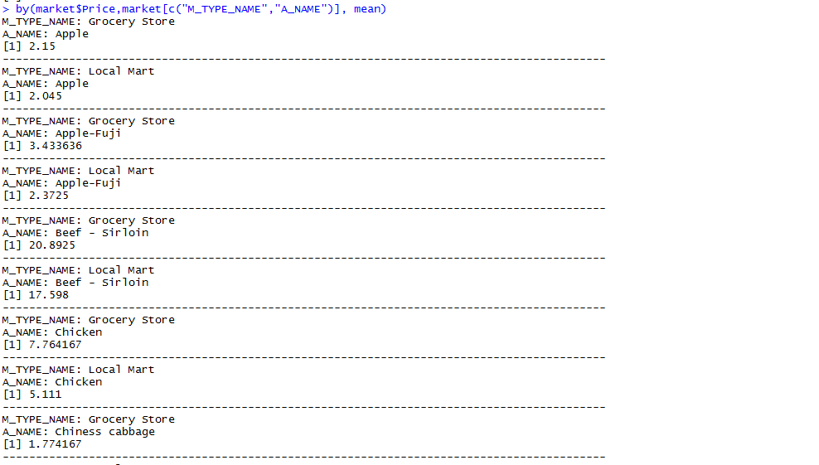

c)

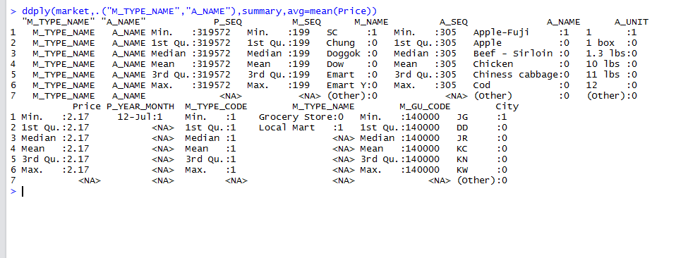

1. Install data.table package (library (data.table). Transform the current data to data table format and name the new data as “market.dt” using data.table() function. If you successfully transformed, the following output will be displayed.

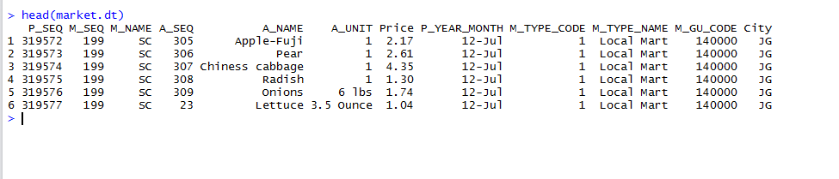



1. Using the “sqldf()” function, display the output below. An example of the sql statement is ("select . . . . , avg(Price) as avg from . . . . group by . . . ").

